**CS 325 – Module 6 – Linear Programming**

* We have a **linear programming problem** if we can specify an objective as a linear function of certain variables, and if we can specify the constraints on resources as equalities or inequalities on those variables
* Page 844+ of course textbook gives example on political problem of gaining the most amount of voters while keeping spending as minimal as possible
  + x1 is number of thousands of $ spent on advertising for building roads
  + x2 is number of thousands of $ spent on advertising for gun control
  + x3 is number of thousands of $ spent on advertising for farm subsidies
  + x4 is number of thousands of $ spent on advertising for gas tax
  + To win at least 50k urban votes, we can formulate …
    - -2x1 + 8x2 + 0x3 + 10x4 ≥ 50
  + To win at least 100k suburban votes, we can formulate…
    - 5x1 + 2x2 + 0x3 + 0x4 ≥ 100
  + To win at least 25k rural votes, we can formulate…
    - 3x1 - 5x2 + 10x3 - 2x4 ≥ 25
  + any setting of the **x** variables that satisfies inequalities yields a strategy that wins a sufficient number of each type of voter. And our goal is to keep spending at a minimum, so we want to minimize the

x1 + x2 + x3 + x4

problem. Although, negative-cost advertising doesn’t exist, therefore it’s required that

* + - x1 ≥ 0, x2 ≥ 0, x3 ≥ 0, x4 ≥ 0
  + Combining inequalities, and with the objective of minimizing, we obtain what is known as a **linear program.** This political problem is formatted as…

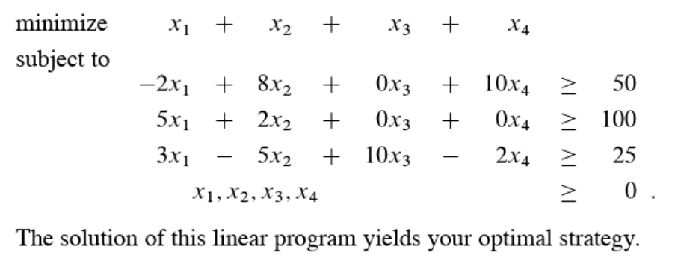

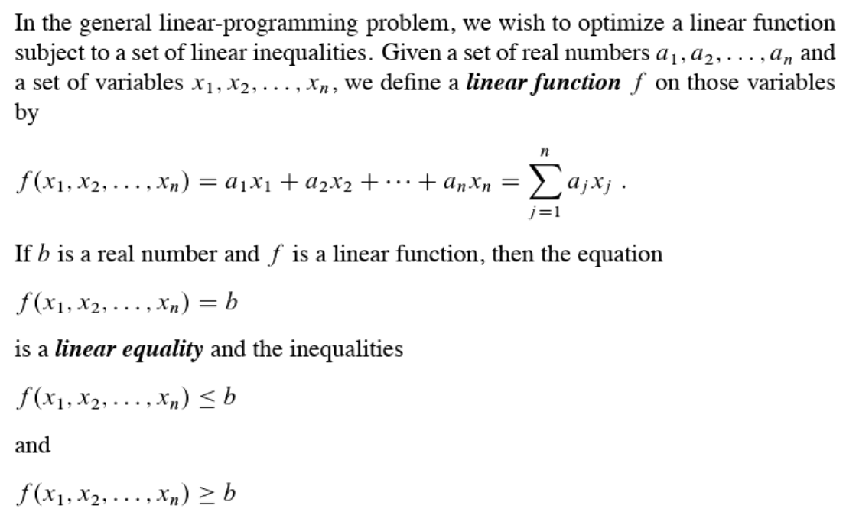

* Linear programming does not allow strict inequalities. Formally, a ***linear-programming problem*** is the problem of either minimizing or maximizing a linear function subject to a finite set of linear constraints (i.e. variable values).
  + If we are to **minimize**, then we call the linear program a ***minimization linear program***
  + If we are to **maximize**, then we call the linear program a ***maximization linear program***
* Each ***linear-programming problem*** (optimization problem) consists of three elements:
  + **decision variables –** describes our choices that are under our control
  + **objective function –** describes a criterion that we wish to minimize (e.g. cost) or maximize (e.g. profit)
  + **constraints –** describes the limitations that restrict our choices for decision variables
* **Breaking down an LP Problem of a company that makes products P and Q using machines A and B**
  + When breaking down an **LP** problem, we first identify our **decision variables** (i.e. what we want to determine among those things which are under our control)
    - **x** = number of units of P
    - **y** = number of units of Q
  + we then seek a **criterion** (or a measure) to compare alternative solutions. This yields the **objective function**
    - We want to maximize the total profit. The profit per each unit of P is $25 and profit per unit of Q is $30. Therefore, the total profit is **25x + 30y if we produce x units of P and y units of Q which leads us to the objective function …**

***max 40x + 35y***

The objective function is linear in terms of decision variables **x and y** (i.e. it is the form **ax + by where a and b are constant**

We typically use the var **z** to denote the value of the objects so the function above could be stated as ***max z = 25x + 30y***

* Next steps…
  + We identify our **constraints** (the things that limit our decisions) which in this case would be the amount of time that machine A takes to make one unit of either P or Q. If we produce x units of P and y units of Q, machine A should be used for **50x+24y** minutes since each unit of P requires 50 minutes processing time on machine A and each unit of Q requires 24 minutes processing time on machine A. On the other hand, machine A is available for 40 hours or equivalently for 2400 minutes. This imposes the following constraint: **50x + 24y ≤ 2400**. Similarly, the amount of time that machine B is available imposes the following constraint: **30x + 33y ≤ 2100**.
  + these **constraints** are linear inequalities since in each constraint the **left-hand side** of the inequality sign is a linear function in terms of the decision vars **x and** **y**  and the right side is constant
  + our constraints are basically x ≥ 0 and y ≥ 0
  + 50x + 24y ≤ 2400, (machine A time)
  + 30x + 33y ≤ 2100, (machine B time)
  + x ≥ 0,
  + y ≥ 0.
  + Here is the full **LP…**
  + max z= 25x + 30y
  + s.t. 50x + 24y ≤ 2400,
  + 30x + 33y ≤ 2100,
  + x ≥ 0,
  + y ≥ 0.
* See ***Tutorial 2*** *for more examples/notes*